DC Railway Traction Supply Protection Integrity & Calibration
Presented at the Railway Engineering Conference 2023
Christopher Langridge MA CPhys MInstP, LML Products Ltd & Riker Ltd
Abstract
DC traction provides fast, clean, quiet and efficient rail transport with minimum visual impact on either urban or rural environments. The substantial traction-supply current needs protection however and its reliability depends on regular maintenance and calibration. Experience over many years has led to protocols for comparing performance between types, measuring stable behaviour, and detecting or predicting likely faults. This paper presents the underlying statistical concepts, compares fundamental characteristics and illustrates the impact of accurate testing and calibrations on the reliability of DC railway traction supply protection.

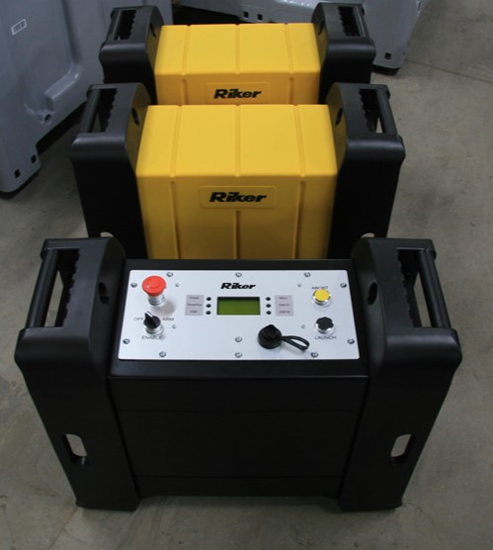

Practical Testing and Calibration
Both factory and on-site testing, with up to 10kA DC typical, are readily accomplished with portable equipment which can be brought on-site with a small van or truck.
The important consideration is how much data is required and how can it be assessed?
There is often an implicit assumption in testing a Traction Supply Circuit Breaker (TSCB) that one can be satisfied with a single typical value for the TSCB’s trip-level. In truth, there will be both stochastic variation and intrinsic drift in the value measured for any specimen and good practice demands assessment of both these factors and the contribution of errors from measurement equipment.

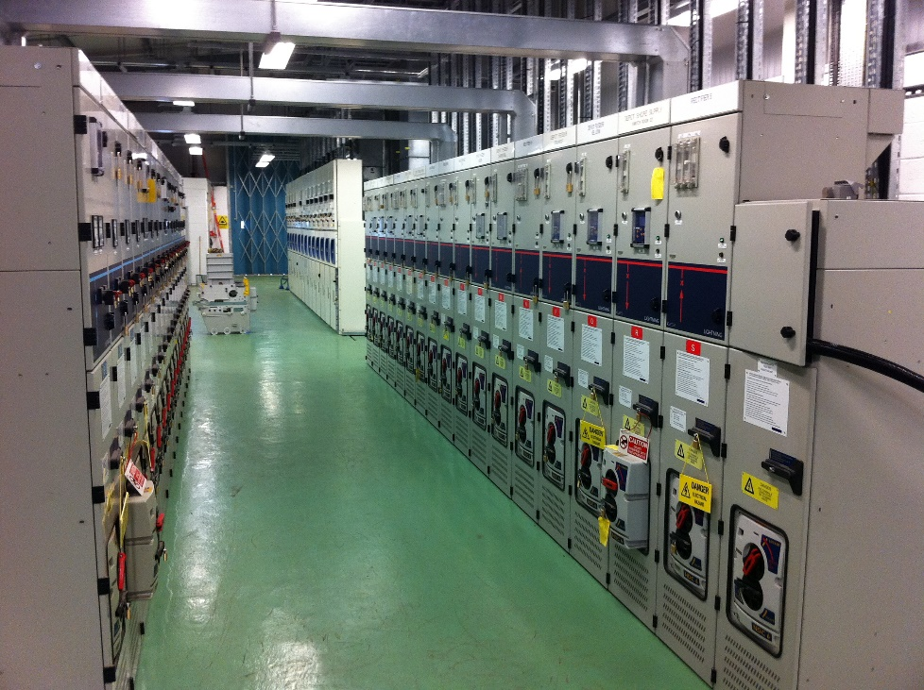
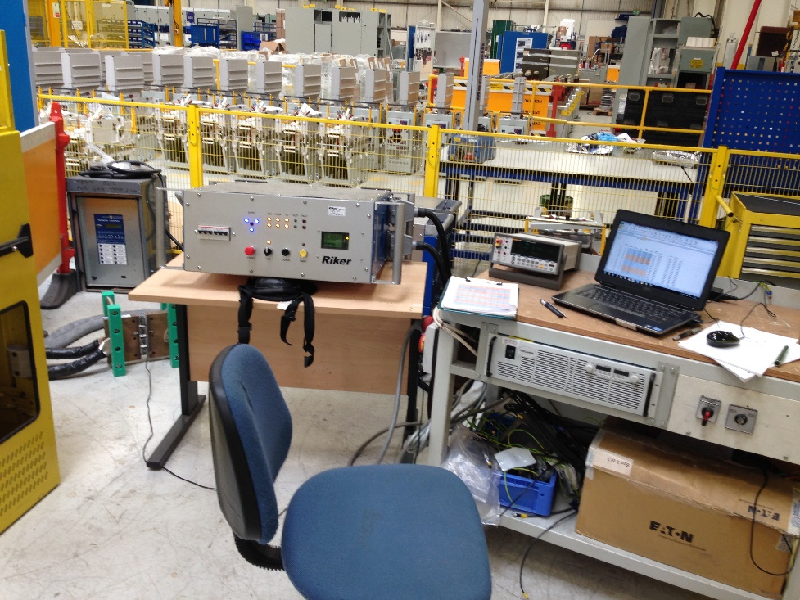
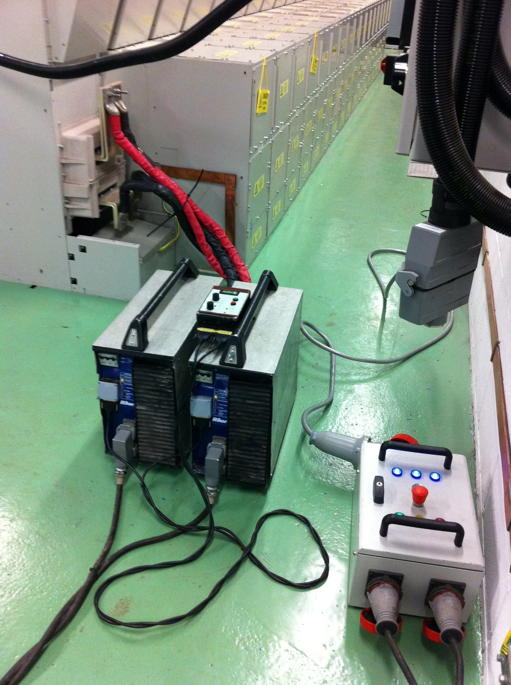

Data Analysis
Regular performance-testing underpins preventative maintenance and fleet reliability. Its core purpose is to harvest data; data which reveals normal variations in behaviour; and data that enables objective comparisons between specimens and across a history of service.
Trip accuracy and repeatability indicate the immediate health of a circuit breaker, but how much data from each specimen is necessary and sufficient for confidence in its contribution to fleet reliability?
GRAPHIC 01
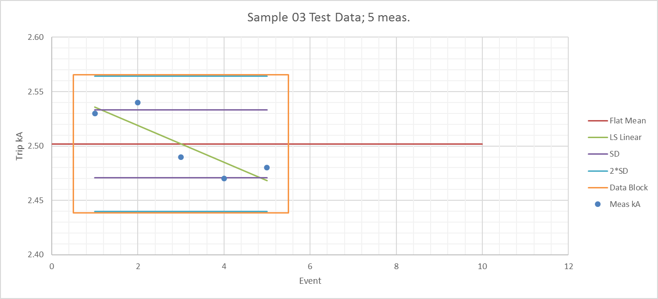
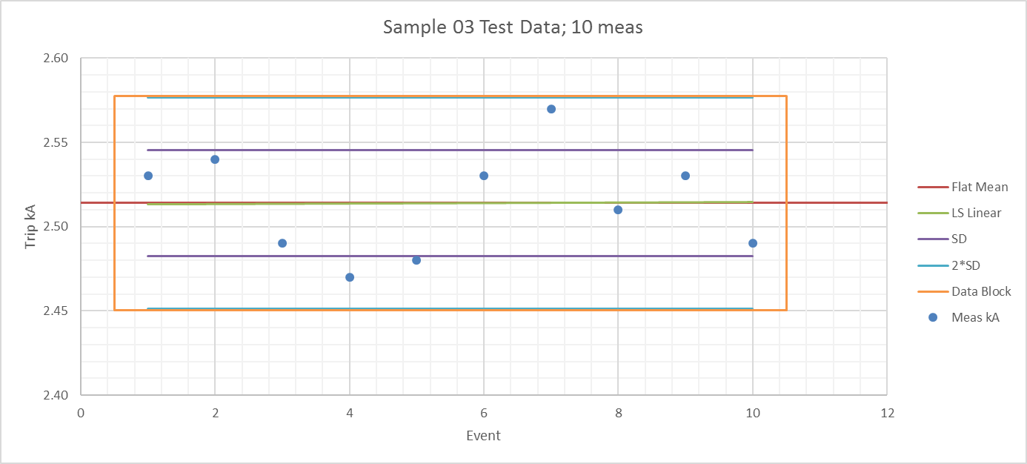
Sample Data Blocks in this graphic represent the first five and first ten measurements from the same data, randomly selected. Shown against an assumed flat mean value, they are broadly contained by the characteristic trip-value uncertainty for the specimen. Without knowledge or assumption of underlying stability, green best-fit performance prediction lines show how natural variations can imply an underlying drift gradient within a small set of measurement and impact the validity of performance assessment.
GRAPHIC 02
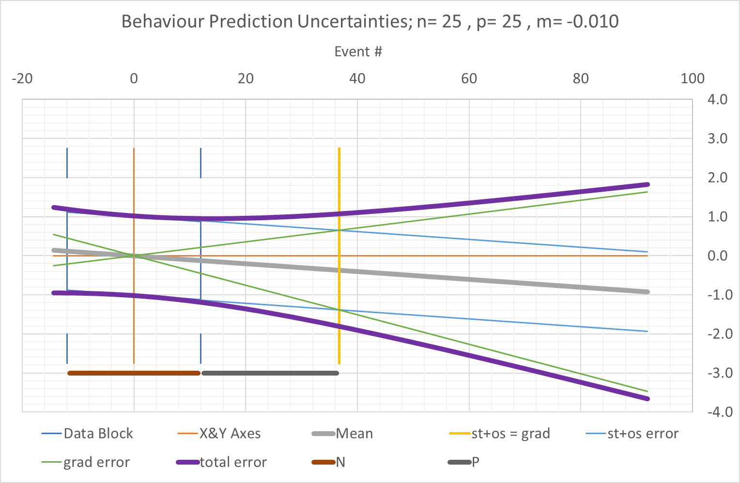

The data block shown here, in dark blue, represents a number of measurements on a true, grey, behaviour line, representing low drift, with light blue lines representing consistent limits of stochastic uncertainty.
The divergent green lines represent drift gradient uncertainty limits; the divergence proportions stochastic uncertainty but reduces with number of measured data.
Total uncertainty, shown in purple, increases rapidly beyond the intercept of gradient and stochastic uncertainties; the prediction limit suggested by this point is solely dependent on number of measured data.
These dependencies on number of measured events suggest basic sampling criteria as shown in Table 01, below.

TABLE 01
Data Points | σ(grad)/σ(meas) | σ(grad)=σ(stoch)  Predictive Projection | Result Validity | Assumptions, Requirements
N | per Event | P
1 | n/a | 0 | Basic Function Only | Stability, Accuracy, Repeatability
5 | 0.32 | 1.5 | Basic Accuracy | Stability
10 | 0.11 | 5 | Basic Accuracy & Stability | Graph Results
15 | 0.06 | 10 | Accuracy, Drift, Variation | Use Regression Analysis
25 | 0.03 | 25 | Accuracy, Drift, Variation | Use Regression Analysis

A single test can be argued as optimal proof of a circuit breaker’s sentinel functionality but, obviously, provides no information on its repeatability.
About 5 tests indicate accuracy in devices assumed to be substantially stable but are limited for variation measurements.
About 10 tests are normally adequate to indicate stability; graphic plots highlight behaviour and any need for further testing.
15-25 tests are required to analyse variation and stability by linear regression.
Larger quantities of data, N(data) = $n$, give σ_{grad}=σ_{stoch} at a distance $b$ , from the data centrum, and a distance $p$, from the last data point, as shown in Table 02 below. For large values of $n$, the value of $b$ is given by $b≅±0.289×n\sqrt{n}$
TABLE 02
N(data) | Grad-Stoch Equality from Centrum |  | Grad-Stoch Equality from Last Datum
n | b | b/n | p
3 | 1.6 | 0.5 | 1
5 | 3.5 | 0.7 | 1
10 | 9.5 | 1.0 | 5
15 | 17 | 1.2 | 10
25 | 37 | 1.5 | 25
50 | 103 | 2.1 | 79
100 | 290 | 2.9 | 241
250 | 1,143 | 4.6 | 1,019
500 | 3,231 | 6.5 | 2,981
1,000 | 9,133 | 9.1 | 8,634
1,000,000 | 288,675,279 | 289 | 288,175,279

Graphics 03A, 03B & 03C: Sampling Illustrations
The following three figures use the same set of 25 tests on a DC circuit breaker on Croydon Tramway, UK. A distorted regression line from stochastic asymmetry in just 5 tests suggests serious instability; increasing to 25 data validates the stability of the measured trip point.
Graphic 03a – 5x Data
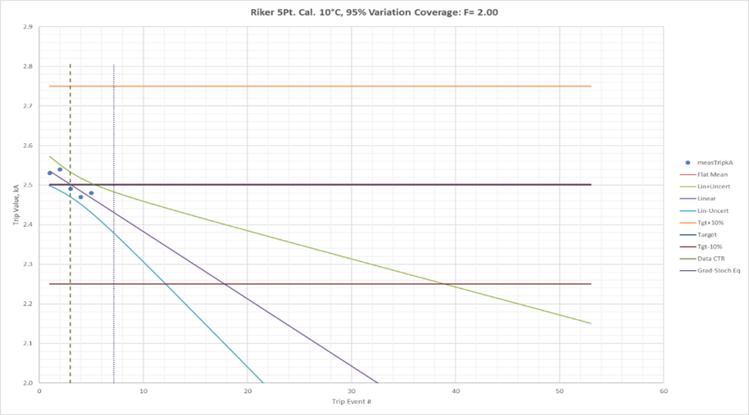
Graphic 03b – 25x Data
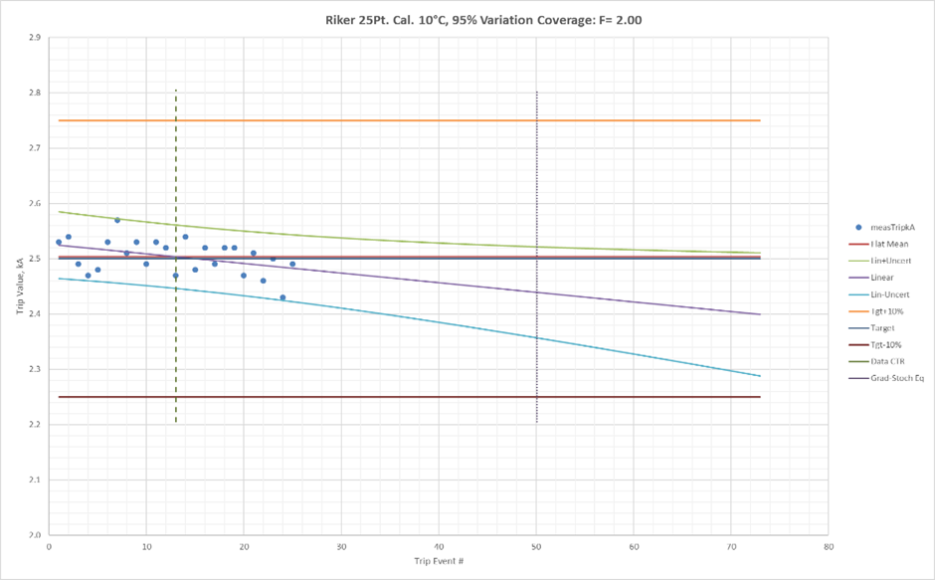
Comparison across Similar Specimens
Regression analysis of raw data separates intrinsic fluctuations and measurement errors from the predictions of core trajectories which enable measurements to be normalised for comparison across similar specimens. As an example, 25 sequential trip tests were carried out on a zero-bias random sample of 17 DC Circuit Breakers specified by UK Network Rail and installed on the North Kent Coast.
GRAPHIC 05
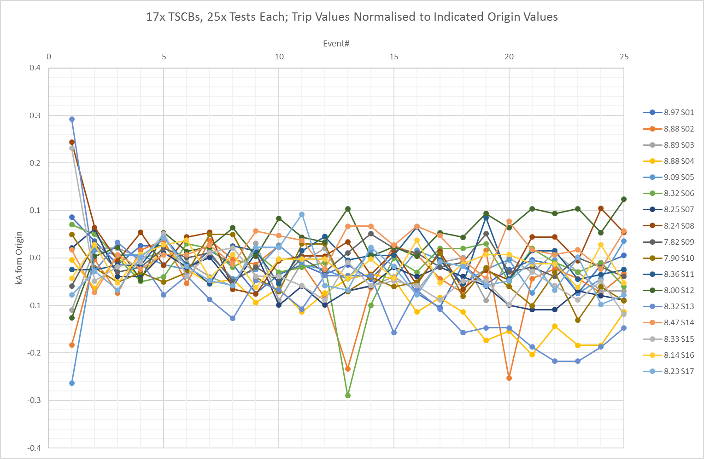
Normalising each specimen’s regression line to zero at event one provides a common origin for the test results. A graphic comparison then highlights several characteristics:
- Firstly, ignoring the initial trip and subsequent outliers, stochastic variation is reasonably consistent, with Standard Deviation ITRO 35 Amps, across the bulk behaviour of all specimens.
- After 25 events, individual core trip drift levels can be measured within 2A and show values roughly between +100 and -200 Amps with an average of -50 Amps; drift measurements which provide objective assessments of projected stability.
- The first trip’s four-fold increased variation is rendered visible and can only be measured by this comparison.
- The graphic also brings into prominence three 250 Amp singularities contributed by two specimens; these can indicate incipient mechanical problems and deserve further investigation.
Quantity of data is therefore crucial to an accurate estimate of future reliability; the following graphics use LSBF linear regression analysis as a basis for estimating true variation and drift gradient. The first two graphics compare the stability of two specimens with assumed linear range (LR) indicated on the second graphic.
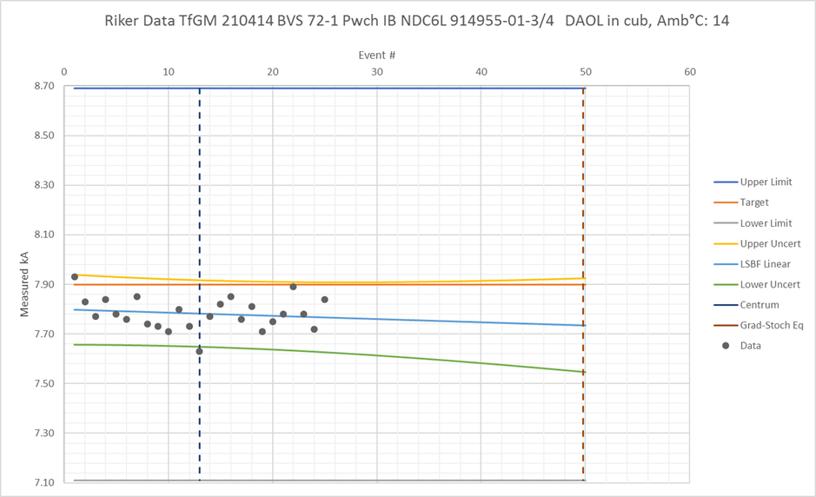

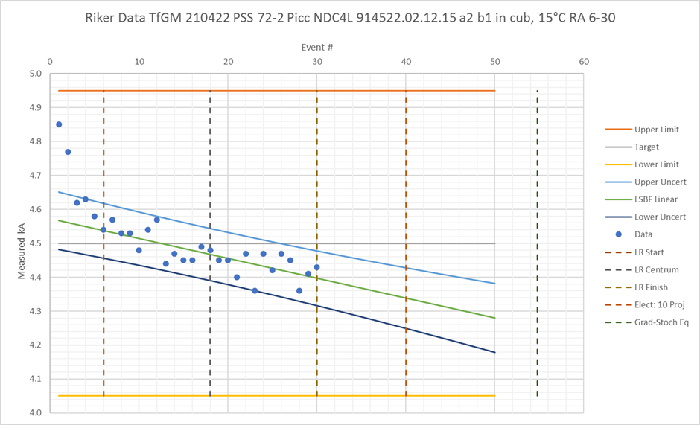

Characteristics have then been collated across types by normalising trip-event paths with a zero regression-line value at the origin to compare collective behaviour across types:

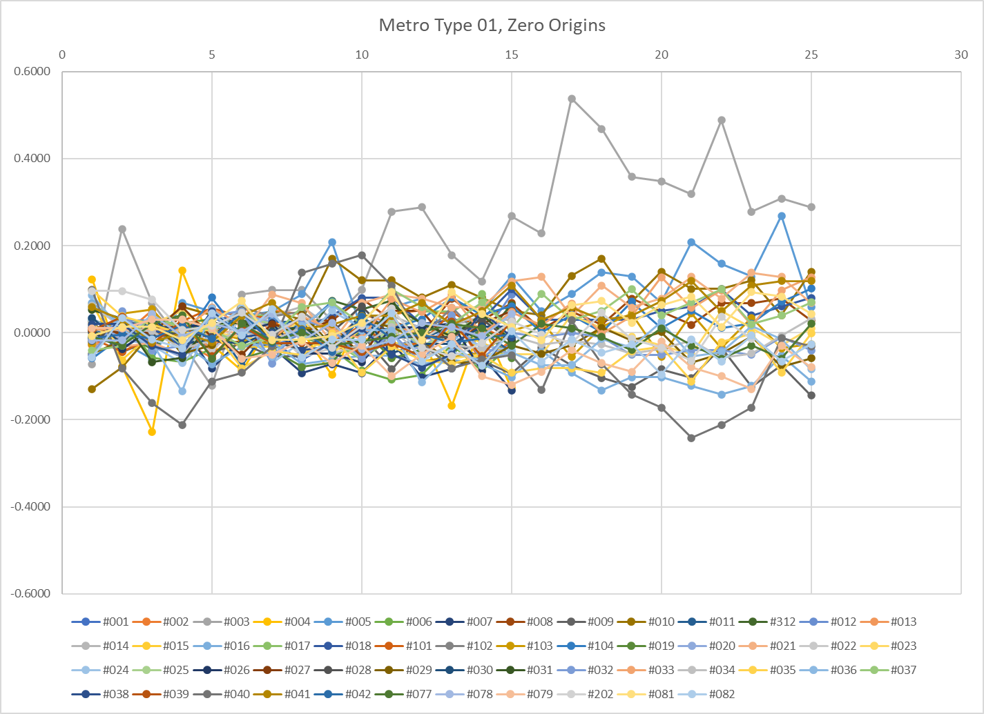

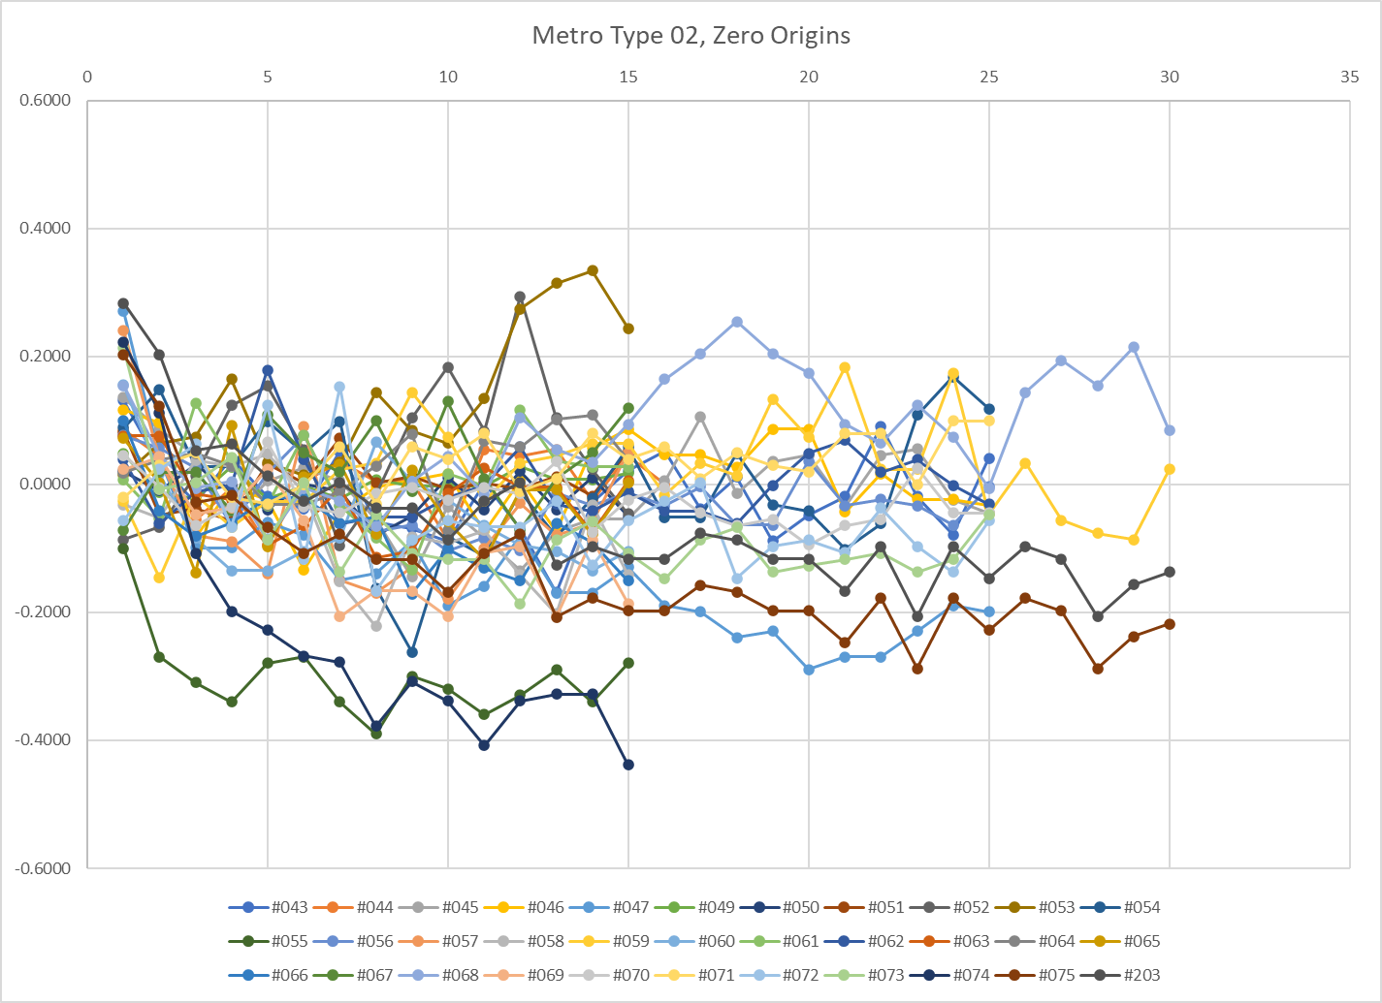
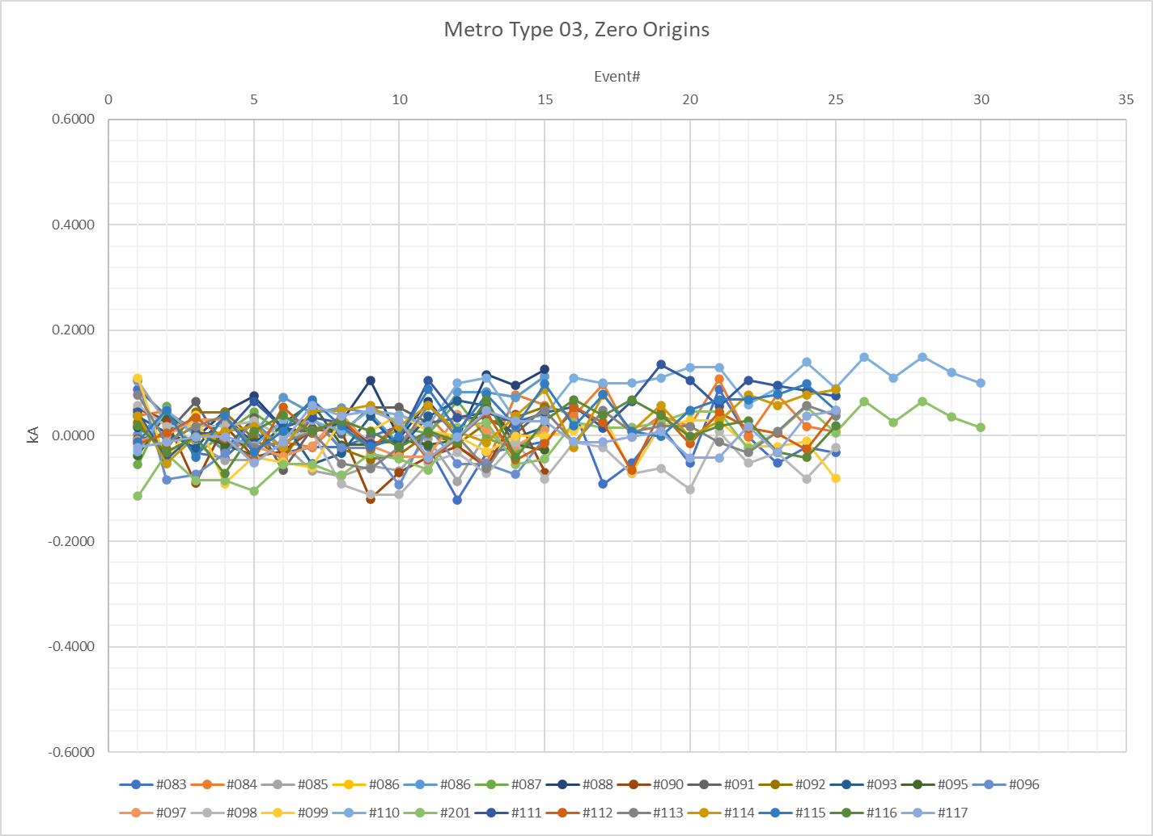
These data provide clear performance references for each type and for individual specimens of each type; the outlying performance trajectory at the top of the Type 01 graphic failed in service the day after testing. In a recent test of about 150 TSCBs on a city metro, 3 significant mechanical faults were detected on TSCBs during basic functionality tests before data collection on trip level. The faults in each case prevented operation of the Direct Acting Over-Load and rendered the TSCB incapable of providing this protection.
Improved Data
The real importance of equipment accuracy is measuring singularities and stochastic variations in TSCB performance without masking from equipment errors. Measured by continuous sampling, continuous AC or DC sources can be controlled to 5ppm or better (50mA at 10kA or 0.0005%). Events and singularities present greater challenges for capture, characterisation, and measurement.
Continuing incremental development has brought greater detail to TSCB performance investigation by improving on-site 10kA trip-measurement errors. Whilst early measurements could measure stochastic variations down to typ. 35A SD (=> 0.35% @ 10kA), developments in instrumentation have brought this down to 3A SD (=> 0.03% @10kA).
Traffic Capacity and operational reliability in a railway are dependent on the accuracy and predictability of Traction Supply Protection. In turn, these depend on the quality of data and analysis arising from regular TSCB exercise and testing.

Precision TSCB tests (meas. SD 3.9A) to same vertical scale (±0.6kA) as previous graphic illustrations
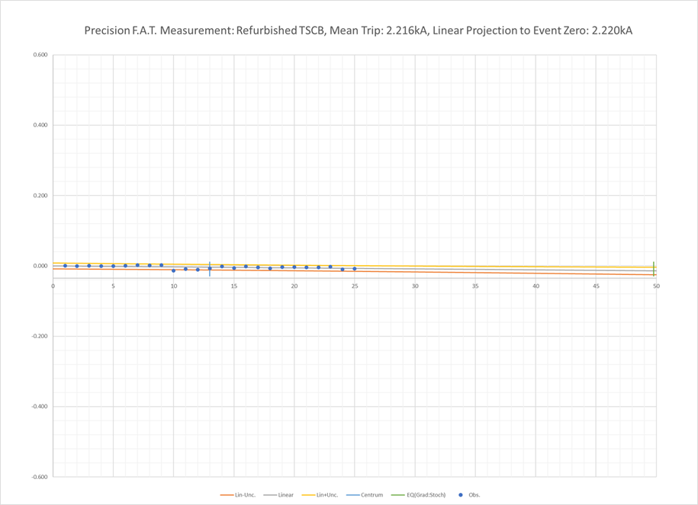
Graphic as above with vertical scale +10A to -25A
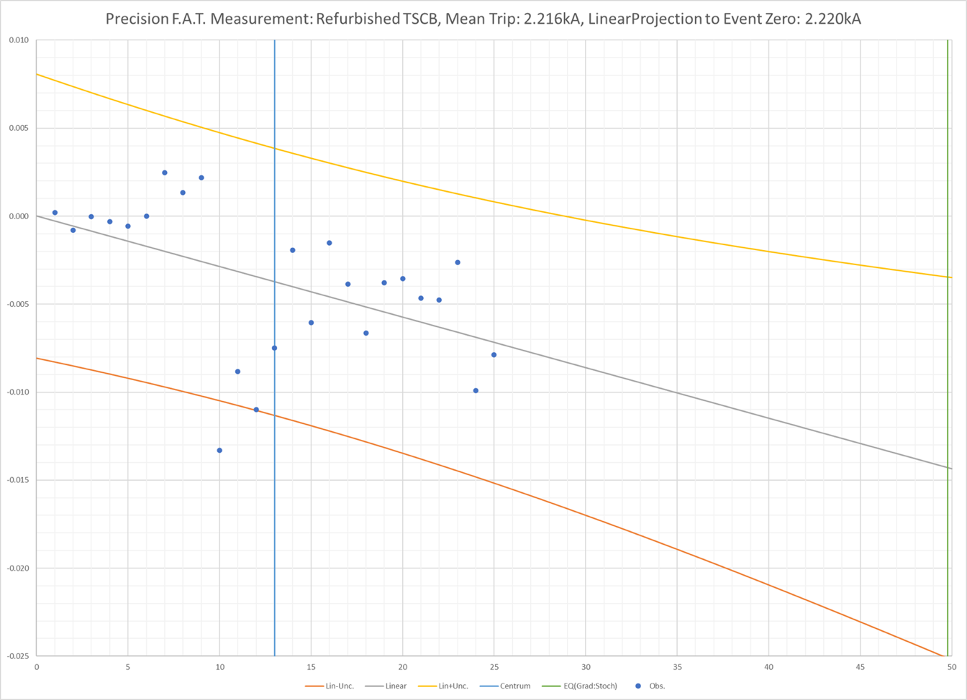

Appendix:

Calculations
& Reference Data

Linear Regression
Linear regression assumes that measured data are derived from an independent variable by core linear variation plus stochastic error fluctuation. Mathematical analysis then defines the parameters of the line best fitting the data plus a quantified estimate of the error fluctuation and its impact on the uncertainties in parameter values. We assume that the separation between tests corresponds to an equal impact for each test and that any movement in core trip value (from setting creep, mechanical wear, material degradation and other rapid-aging factors) is small enough to be linear WRT successive tests. Stochastic variations arise from mechanical instabilities and measurement errors. During service, further time-dependent effects result from corrosion, lubricant loss or thermal degradation of connections and materials.
If a set of tests produces measurements, $z_{i}$, related to $x_{i}$ where $i = 1 to n$, then we seek the best continuous line $y = mx +c$ fitting the data points at any value for $x$. (Whilst $i$ takes ordinal values, increments in the cardinal values for $x$ represent the impact of tests on the specimen.) The most common distribution of stochastic errors, the Gaussian (or Normal) distribution proportions the probability of a given error to the inverse exponential of its square. The probability of multiple errors, given by the product of individual probabilities, therefore proportions the sum of squared errors:
$P(x)=Aexp\left(-\frac{x^{2}}{σ^{2}}\right)dx$ and $P\left(x_{1},x_{2}….x_{n}\right)= A^{n}exp\left(-\frac{\sum{{x_{i}}^{2}}}{σ^{2}}\right)dx_{1}{dx}_{2}…{dx}_{n}$
If we therefore take the minimum sum of squared deviations from linear as our criterion for best fit, then we must find the combination of $m \& c$ that minimises $S$, where:
$S=\sum_{i=1}^{n}{{\left(z_{i}-mx_{i}-c\right)}^{2}}$ LR01
Differentiating WRT $m$ & $c$:
$$\frac{∂S}{∂m}=-2\sum_{i}{\left(z_{i}x_{i}-mx_{i}x_{i}-cx_{i}\right)}$$
LR02
$$\frac{∂S}{∂c}=-2\sum_{i}{\left(z_{i}-mx_{i}-c\right)}$$
Both 2nd differentials are positive and so equating the first differentials to zero produces the required minimum for S. Dividing each equation by n and solving for m & c gives the required parameter values for the Least-Squares Best-Fit Line ($\overline{z}$denotes the average value for $z$ across the set of measurements).

$m=\frac{\overline{zx}-\overline{z}.\overline{x}}{\overline{xx}-\overline{x}.\overline{x}}$ and: $c=\frac{\overline{z}.\overline{xx}-\overline{zx}.\overline{x}}{\overline{xx}-\overline{x}.\overline{x}}$ LR03

Note that if $\overline{x}=0$:
$m=\frac{\overline{zx}}{\overline{xx}}$ and: $c=\overline{z}$ LR04

Errors in calculated values for $m$ & $c$
If we could make an infinite number of measurements, then, for each $i$-value, $z_{i}$-values will be centred on a mean given by the “True Line” Y-value (= Mx +C) and distributed with standard deviation = σ_{i}. If
we assume that this value is the same for each measurement $(σ_{i}= σ, all i)$, then we can consider the effect of fixing each of the measurement-point values $x_{i}$ and making multiple sets of measurements, $z_{ji}$, across this fixed set of $x$-values. For the sake of simplicity, we can take a frame of reference where $\overline{x}=0$ so that the Best-Fit Line has parameters given by:

$m_{j}=\frac{\overline{z_{ji}x_{i}}}{\overline{x_{i}x_{i}}}$ $=\frac{\sum_{i}{z_{ji}x_{i}}}{\sum_{i}{x_{i}x_{i}}}= \frac{1}{D}\sum_{i}{z_{ji}x_{i}}$ , (where $D=\sum_{k}{{x_{k}}^{2}}$) and: $c_{j}=\overline{z_{j}}=\frac{1}{n}\sum_{i}{z_{ji}}$ LR05
We need to know how these calculated values for gradient, $m$, and offset, $c$, depend on the likely errors in the values measured for the $z_{ji}$. For a given line (=> given value of $j$), the total error in each parameter will be compounded from the effects of errors in $z_{ji}$ for each value of $i$ so that, the total error in each parameter is given by:
${∆m}_{j}=\sum_{i}{\frac{∂m_{j}}{∂z_{ji}}}∆z_{ji}=\frac{1}{D}\sum_{i}{x_{i}}∆z_{ji}$ and: ${∆c}_{j}=\sum_{i}{\frac{∂c_{j}}{∂z_{ji}}}∆z_{ji}=\frac{1}{n}\sum_{i}{∆z_{ji}}$ LR06
Squaring these expressions gives:
${\left({∆m}_{j}\right)}^{2}=\frac{1}{D^{2}}\sum_{i}{{\sum_{k}{x_{i}}x}_{k}}∆z_{ji}∆z_{jk}$ and: ${\left({∆c}_{j}\right)}^{2}=\frac{1}{n^{2}}\sum_{i}{\sum_{k}{∆z_{ji}∆z_{jk}}}$ LR07
Taking the “whole-world” average across all possible sets (denoted by $〈relevant variables〉$); the component of whole-world average $〈\sum_{k}{∆z_{jk}}〉$ is zero so that cross-terms in $i$ & $k$ have zero average and the non-zero terms give the results:
$〈{\left(∆m\right)}^{2}〉=\frac{1}{D^{2}}\sum_{k}{x_{k}}{x_{k}σ}^{2}=\frac{σ^{2}}{D}$ and: $〈{\left(∆c\right)}^{2}〉=\frac{1}{n^{2}}\sum_{k}{σ^{2}}=\frac{σ^{2}}{n}$ LR08

Likely True Value of SD, $σ$, Estimated from Observed SD, $s$.
We know the observed Standard Deviation of stochastic errors, $s$, measured with respect to LS Best-Fit Lines. The intrinsic SD of the underlying stochastic behaviour, $σ$, relates to the True Line however and we need to determine the relationship between these quantities.
Using the same model providing $m$ and $c$ values in LS Best-Fit Lines; where $z_{ji}$ represents the $z$-measurement for $x_{i}$, the $i$^{th} fixed $x$-value in the $j$^{th} set of line-data; $d_{ji}$ represents the error in $z$ WRT the Best-Fit Line and $e_{ji}$ represents the error WRT the True Line.
$d_{ji}=z_{ji}-m_{j}x_{i}-c_{j}$ and $e_{ji}=z_{ji}-Mx_{i}-C$ LR10
Giving: $e_{ji}=d_{ji}+\left(m_{j}-M\right)x_{i}+\left(c_{j}-C\right)$ LR11
We have defined the True Line as $Y_{i}=Mx_{i}+C$ ; since $\sum{x_{i}}$ =0, we can add across all values of $i$ to obtain $C$ and multiply by $x_{i}$ then add across all values of $i$ to obtain $M$:
$M=\frac{1}{D}\sum{Y_{i}x_{i}}$ and $C=\frac{1}{n}\sum{Y_{i}}$ where $D=\sum{x_{i}^{2}}$ LR12
Which combine with LR05 to give:
$\left(m_{j}-M\right)=\frac{1}{D}\sum_{i}{\left(z_{ji}-Y_{i}\right)x_{i}}=\frac{1}{D}\sum_{i}{e_{ji}x_{i}}$ and $\left(c_{j}-C\right)=\frac{1}{n}\sum_{i}{e_{ji}}$ LR13
These substitute into LR11 to give the relationship between $e_{ji}$ and $d_{ji}$:
$e_{ji}=d_{ji}+\frac{x_{i}}{D}\sum_{k}{e_{jk}x_{k}}+\frac{1}{n}\sum_{k}{e_{jk}}$ LR14
On squaring both sides and summing over $i$, the non-zero terms give:
$\sum{{e_{j}}^{2}}=\sum{{d_{j}}^{2}+\frac{1}{D}}{\left(\sum_{k}{e_{jk}x_{k} }\right)}^{2}+\frac{1}{n}{\left(\sum_{k}{e_{jk}}\right)}^{2}+ \frac{2}{D}\sum_{i}{{d_{ji}x}_{i}\sum_{k}{e_{jk}x_{k}}}$ LR15
Averaging LR15 over all sets reduces the last term to zero. The remaining (non-zero) terms, based on the SD of observed errors, $s$, in Best Fit Lines, then give the best estimate for the SD of intrinsic errors, $σ$, relating to the True Line as:
$$nσ^{2}=n〈s^{2}〉+σ^{2}+σ^{2}$$ or LR16
$$σ^{2}=\frac{n}{\left(n-2\right)}〈s^{2}〉$$

Variation and Uncertainty
The uncertainty in a measurement represents the coverage of stochastic variation provided by defined limits. The limits are determined by a coverage factor multiplied by the standard deviation of the variable or parameter concerned. Assuming a Normal (= Gaussian) distribution of errors, key coverage factors are tabulated below:
Table AT01
 | Coverage Factor, k | Variation Coverage, %
 | 1.96 | 95.0
 | 2.00 | 95.4
 | 2.50 | 98.8
 | 2.58 | 99.01
 | 2.60 | 99.07
 | 3.30 | 99.90
 | 3.90 | 99.990
 | 4.40 | 99.9989
 | 4.42 | 99.9990
 | 4.90 | 99.99990

As an example, limits within ±2.5σ of the mean (=expected value ±2.5x SD error variation) will cover about 99% of possible results.
Gradient and Stochastic Uncertainties
For $n$ data points, $x$, where $x =1 to n$ so that ($\overline{x}=\frac{\left(n+1\right)}{2}$), gradient errors are given by LR08 as:
$$〈{\left(∆m\right)}^{2}〉={σ^{2}}/{\sum{r^{2}}}$$
Where $r, =\left(x-\overline{x}\right),$ is the separation of each data point from the centrum and:
$$\sum{r^{2}}=\sum_{i=1}^{n}{{\left(x_{i}-\overline{x}\right)}^{2}=\sum{\left(x_{i}^{2}-{\overline{x}}^{2}\right)}}=\frac{n\left(n+1\right)\left(2n+1\right)}{6}-\frac{n{\left(n+1\right)}^{2}}{4}=\frac{n\left(n-1\right)\left(n+1\right)}{12}$$
(LR17) Which gives:
$$〈{∆m}^{2}〉={σ^{2}}/{\sum{r^{2}}}=\frac{12σ^{2}}{n\left(n^{2}-1\right)} LR18$$

Point of Equality for Gradient Uncertainty and Stochastic-plus-Offset Uncertainty
At a distance, $b$, from the centrum, total variance contributions caused by gradient variance, $V_{G}$ and stochastic plus offset variance, $V_{(S+O)}$ are given by:
$$V_{G}={ b}^{2}〈\left({∆m}^{2}\right)〉={ b}^{2}{σ^{2}}/{\sum{r^{2}}} LR19a$$
And
$$V_{(S+O)}=σ^{2}+〈{\left(∆c\right)}^{2}〉=\frac{σ^{2}\left(n+1\right)}{n} LR19b$$
$V_{G}=V_{(S+O)}$ now gives : $\frac{σ^{2}\left(n+1\right)}{n}={ b}^{2}{σ^{2}}/{\sum{r^{2}}} LR20$ so that, Substituting for $\sum{r^{2}}$ from LR17:
$$b^{2}=\frac{\left(n+1\right)}{n}\sum{r^{2}=} \frac{{\left(n+1\right)}^{2}\left(n-1\right)}{12} LR21$$

This gives positive or negative roots for b corresponding to future or past events:
$$b=\frac{±\left(n+1\right)}{2}\sqrt{\frac{n-1}{3}} LR22$$

$$or: b≅±0.289×\left(n+1\right)\sqrt{n-1}$$
(For large $n$-values: $b^{2}≈\frac{n^{3}}{12}$ , $b≅±0.3×n\sqrt{n}$ and $b/n≅±0.3×√n$)
The point where $V_{G}=V_{(S+O)}$ is given by $x_{eq}=x ̅+b=((n+1))/2+b$.
Predicted Behaviour - Projection from Measured Data
Projecting forward from measured data, initial uncertainty in predicting mean values from the core regression line is largely determined by the combined stochastic and offset errors. Beyond the equality point, calculated above, gradient errors become more significant and divergent uncertainty dilutes the predictive value of the projection. The calculated equality point is therefore a significant determinant of predictive limits, determined solely by the number of measured data.
The distance from the centrum to the last measured datum is given by $n-\overline{x}=\frac{\left(n-1\right)}{2}$ and the projection from the last datum to the point where $V_{G}=V_{(S+O)}$ is therefore given by:
$$p=b-\frac{\left(n-1\right)}{2} LR23$$
Graphic AG01 illustrates dominance of gradient variance beyond the $V_{G} = V_{(O+S)}$ equality point and values for b & p for 25 data points, $x$, where $x$ = 1 to 25. Values for $b$ and $p$, for various values of $n$ where $x = 1 to n$, are tabulated in AT02.
Graphic AG01
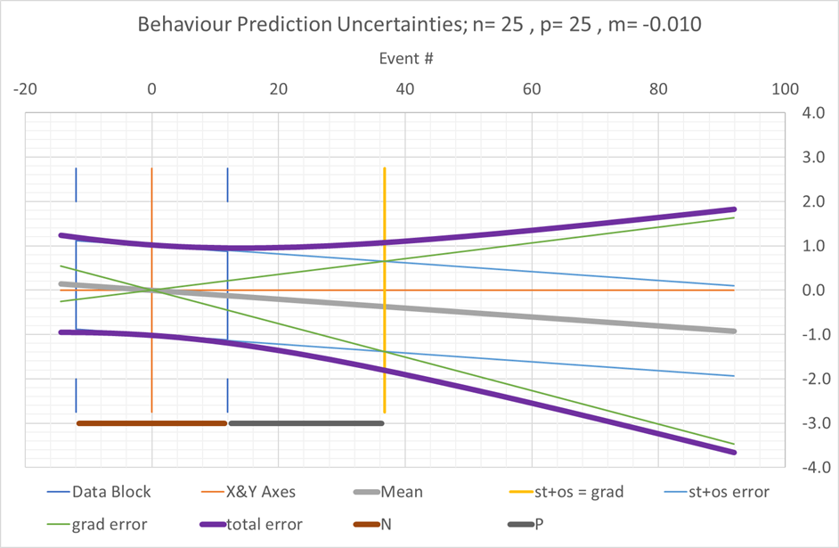

Table AT02
N(data) | Grad-Stoch Equality from Centrum |  | Grad-Stoch Equality from Last Datum
n | b | b/n | p
3 | 1.6 | 0.5 | 1
5 | 3.5 | 0.7 | 1
10 | 9.5 | 1.0 | 5
15 | 17 | 1.2 | 10
25 | 37 | 1.5 | 25
50 | 103 | 2.1 | 79
100 | 290 | 2.9 | 241
250 | 1,143 | 4.6 | 1,019
500 | 3,231 | 6.5 | 2,981
1,000 | 9,133 | 9.1 | 8,634
1,000,000 | 288,675,279 | 289 | 288,175,279

Combination of Errors, or Uncertainty, by Convolution
A parameter’s value at a given point may be affected by multiple sources of variation; for example, gradient and stochastic errors. If the probability density functions for two contributing sources of variation are given by $P_{1}\left(y_{1}\right)$ and $P_{2}\left(y_{2}\right)$ Then the overall probability density function for the parameter having a particular value, z, is given by the probability of all possible combinations of y₁ & y₂ that produce z. If z = y₁ + y₂, then this clamps the interdependence of y₁ & y₂ and the probability density for the parameter at the value z is given by:
$$P\left(z\right)=\left(P_{1}*P_{2}\right)\left(z\right)=\int_{-∞}^{∞}{P_{1}\left(x\right)}.P_{2}\left(z-x\right)dx C01$$
In the case where both P1 &P2 are Gaussian:
$$P\left(z\right)=\int_{-∞}^{∞}{A_{1}exp\left\{-\frac{x^{2}}{{2σ}_{1}^{2}}\right\}}.A_{2}exp\left\{-\frac{{\left(z-x\right)}^{2}}{2σ_{2}^{2}}\right\}dx C02$$
Substitute
$$\frac{1}{{2s}^{2}}=\frac{1}{{2σ}_{1}^{2}}+\frac{1}{{2σ}_{2}^{2}} C03$$
To give:
$$P\left(z\right)=\int_{-∞}^{∞}{A_{1}A_{2}exp\left\{-\frac{z^{2}}{{2σ}_{2}^{2}}\right\}}.exp\left\{\frac{z^{2}s^{2}}{{2σ}_{2}^{4}}\right\}.exp\left\{-{\left(\frac{x}{s\sqrt{2}}-\frac{zs}{σ_{2}^{2}\sqrt{2}}\right)}^{2}\right\}dx C04$$
$$=A_{1}A_{2}s\sqrt{2π}exp\left\{-\frac{z^{2}}{{2σ}_{2}^{2}}\right\}.exp\left\{\frac{z^{2}s^{2}}{2σ_{2}^{4}}\right\} C05$$
$$=Aexp\left\{-\frac{z^{2}}{2\left(σ_{1}^{2}+σ_{2}^{2}\right)}\right\} C06$$
Where A_{n} are normalization constants $=1/(σ_{n}√2π)$.
For Gaussian distributions, the variance (squared standard deviation) for the convolution is therefore the sum of the variances for the original functions.
This can be used to calculate the combined effects of direct stochastic variation and gradient variation at a given projection from the centrum of measured data.

