Optimum Electrical Power Conductors: Key Factors that Minimise Losses and Maximise Service Life
Presented at the Railway Engineering Conference 2023
Christopher Langridge MA CPhys MInstP, LML Products Ltd & Riker Ltd
Abstract
This paper examines the mechanisms differentiating stable and unstable thermal behaviours in power conductors based on the intrinsic variations of physical properties with temperature. A resistance-based linear temperature scale, dependent on conductor material, simplifies the calculation of critical behaviour boundaries and enables calculation of stability parameters and limitations for cables and conductors both at equilibrium with their environment and when constrained by end-cooling.
The specific properties and behaviours of stranded cables are outlined first to pre-empt description of thermal stability limits in all conductors.
FEA models and case studies illustrate the results.
Optimum Electrical Power Conductors: Executive Summary
This paper examines the detailed characteristics of stable and unstable thermal behaviour in electrical conductors and the definition of boundaries between these behaviours.
Stranded and Solid Conductors
Compared to dissipation into air, the high thermal conductivity of copper or aluminium gives accurate results from modelling thermal properties with respect to axial distance only. Many applications however require the flexibility of stranded, or laminated, conductors whose surfaces can dissipate heat to the environment but enclose internal layers at risk of isolation and over-heating. Finite Element Analysis (FEA) of radial temperature distributions shows the possible impact of stranding on the thermal behaviour of cables as opposed to solid conductors; results which correspond to laboratory measurements and field observations. Over-heating can reach extreme levels as current-density increases.

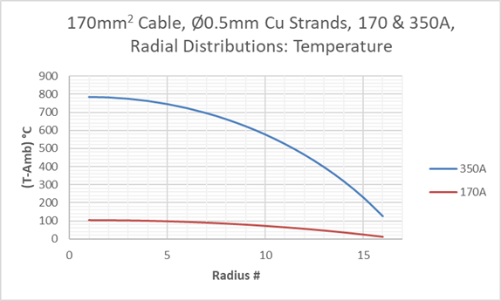

End-cooling in short lengths of stranded cable can however mitigate the effects of poor radial heat dispersion by axial heat extraction from each strand and it is therefore important to realise the caveats raised by construction issues in modelling the performance of a conductor comprising individual elements. High internal temperatures can otherwise cause immediate risks under high loads plus incremental and irreversible damage over time. Successful description of conductor behaviour therefore requires all factors to be included within the holistic models outlined in this paper.
Thermal Behaviour Models and Central Differential Equation
Thermal stability is paramount for safe and efficient conduction of load current and stability depends on the variation of conductor properties with temperature. Behaviour models are simplified by a Zero Resistivity Reference Temperature, $T_{z}$, projected back from linear variation over “engineering” temperatures, typified by the behaviour of copper shown below.
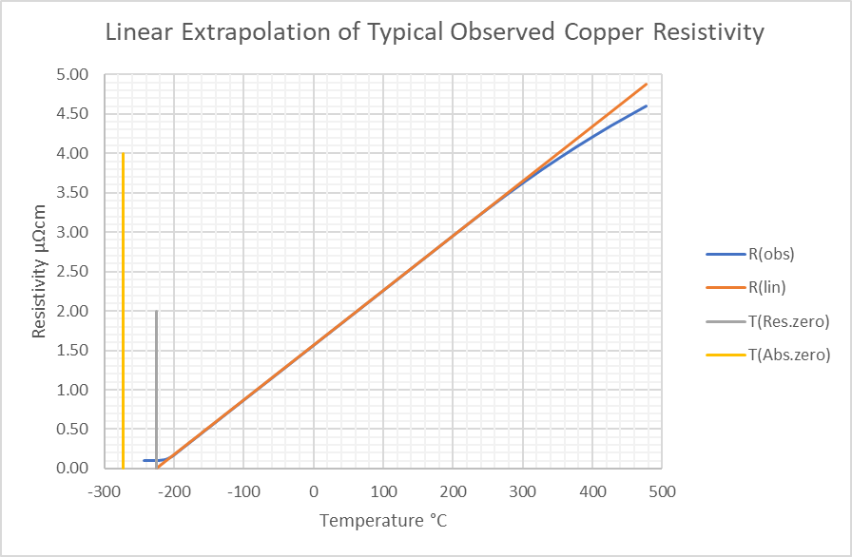
Thermal dissipation is determined by temperature difference from Ambient. Respective temperature dependencies for resistive heating $U$ and Newtonian cooling $N$ combine with localised net heat flux with dependency $D$ on curvature in axial temperature variation to produce the Central Differential Equation (CDE) below:
$$\frac{∂T}{∂t}=D\frac{∂^{2}T}{∂x^{2}}+U\left(T-T_{z}\right)-N\left(T-T_{a}\right)$$
Solutions with Zero Axial Variation
Long conductors under constant conditions, without end-effects or other disruptions are described by a simplified equation with Zero Axial Variation (ZAV) whose solutions reveal basic temperature behaviour and stability limits:
- Whilst $\left(U-N\right)$ remains negative, temperature converges to an equilibrium asymptote.
- If $U=N$, temperatures escape equilibrium; linear increase over time is unlimited.
- When $\left(U-N\right)$ becomes positive, temperature divergence accelerates without limit.

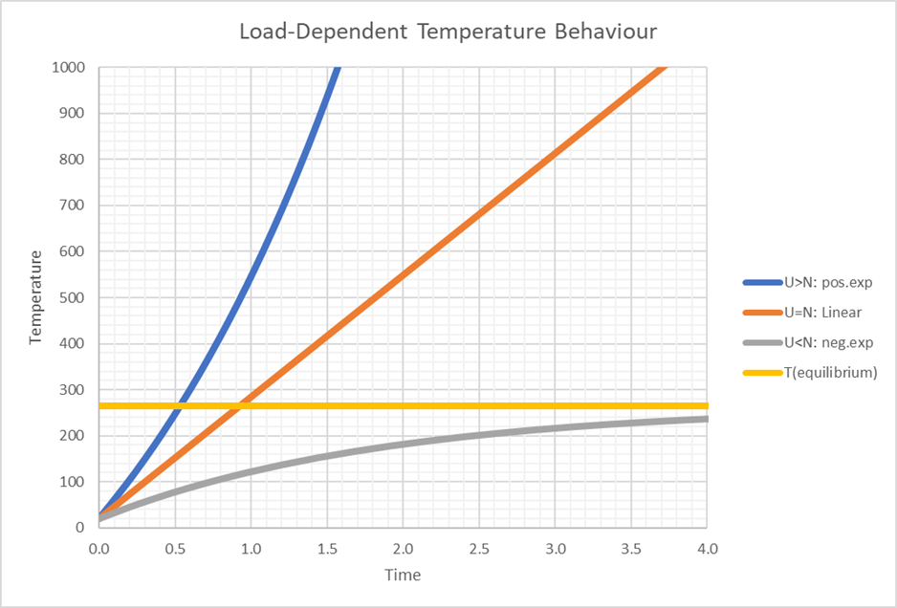
Axial Temperature Distributions
Including axial-distance variation, the CDE produces solutions which determine requirements for stability over distance and time:
- Stability in unrestrained conductors retains the requirement for $U<N$ to establish equilibria in long conductors but there are differences when merging end-effects and bulk ZAV behaviour. Localised individual temperature disturbances disperse over time.
- For $U≥N$, unrestrained conductors are unstable; temperatures diverge without limit. High currents amplify temperature disturbances to localise potential destructive failure.
- Termination heat-sinks can still control stranded conductors with end-cooling stabilising all internal filaments. Simple calculation of a critical length provides the maximum peak temperature for a suitable conductor, as illustrated below.

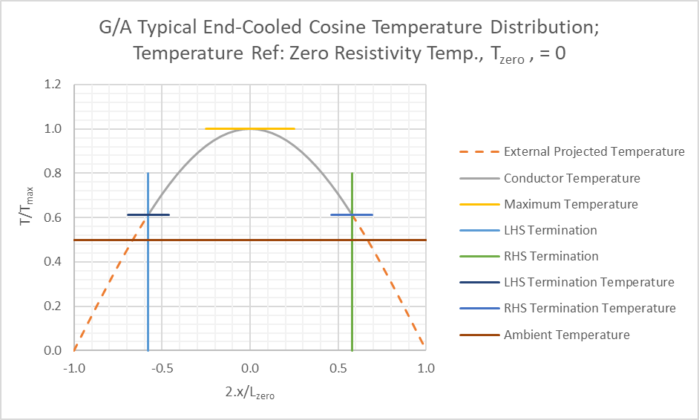

Optimum Electrical Power Conductors: Main Text
Solid and Stranded Conductor Characteristics
Compared to dissipation into air, the high thermal conductivity of solid copper or aluminium imparts near-zero temperature differences over distances equivalent to conductor diameter; accurate results are obtained from modelling thermal properties with respect to axial distance only. The strands comprising flexible cables must however be modelled as independent individuals; mutual interfaces provide minimal transmission of phonons or electrons and confine electrical and thermal behaviour to intra-strand properties. Bending, tension or compression, and diffusive heat transfer across air-gaps provide many stochastic influences which confuse the extent of thermal and electrical contact between strands. Measurements reveal the possibility of near-zero inter-strand electrical conduction over distances exceeding 25,000 filament-diameters.
Even using generous inter-filament heat transfer coefficients, Finite Element Analysis (FEA) reveals the impact of stranding on the thermal behaviour of cables as opposed to solid conductors; as shown below. The results have close correspondence to physical evidence from field applications.
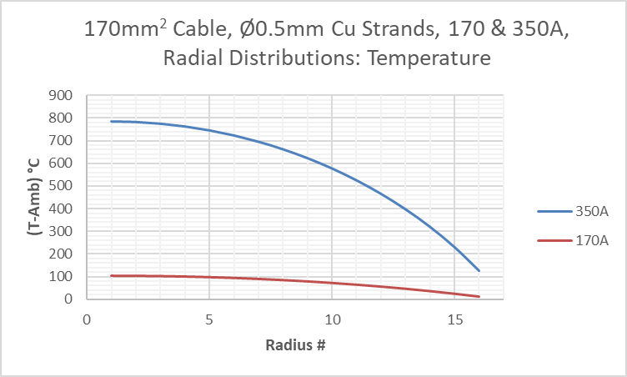
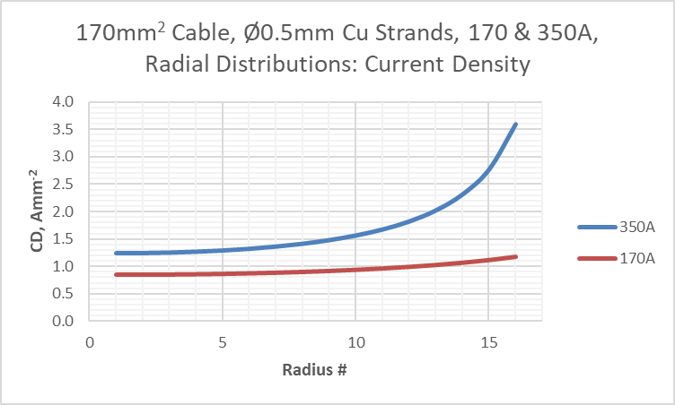
 | Attribute | Load (A) | Solid Conductor | Stranded Conductor
 | Surface Temperature, °C | 170 | 12.1 | 13.5
 | Central Core Temperature, °C | 170 | 12.1 | 102.7
 | Core-Surface Temp. Difference, °C | 170 | 0.0006 | 89.2
 | Total Resistive Dissipation, W per linear metre | 170 | 2.70 | 3.28
 | Relative Dissipation, factor | 170 | 1.00 | 1.22
 | Surface CD, Amm⁻² | 170 | 1.00 | 1.168
 | Central Core CD, Amm⁻² | 170 | 1.00 | 0.852
 | (Core CD)/(Surface CD), factor | 170 | 1.00 | 1.37
 | Surface Temperature, °C | 350 | 62.0 | 124
 | Central Core Temperature, °C | 350 | 62.0 | 784
 | Core-Surface Temp. Difference, °C | 350 | 0.0028 | 660
 | Total Resistive Dissipation, W per linear metre | 350 | 13.9 | 30.31
 | Relative Dissipation, factor | 350 | 1.00 | 2.18
 | Surface CD, Amm⁻² | 350 | 2.06 | 3.58
 | Central Core CD, Amm⁻² | 350 | 2.06 | 1.25
 | (Core CD)/(Surface CD), factor | 350 | 1.00 | 2.85

It is important to realise the caveats raised by construction issues as an integral part of modelling the performance of conductor elements. High internal temperatures can produce multiple damaging effects on conductor elements:
- Increased resistance of internal elements.
- Irreversible oxidation damage.
- Irreversible resistivity damage from diffusion of filament-coatings (e.g. tin or nickel).
- Localised runaway thermal excursions and catastrophic failures.

The only mitigations for these effects are:
- Control of current loading to prevent internal damage.
- Forms of braiding which equalise pathway and surface excursions for all braided elements.
- The effects of end-cooling. Terminations transfer both electrical current and heat between filaments or laminae and the connection-recipient may be able to dissipate heat from a finite length of connected cable or laminated conductor (this current-dependent length-limit is explained later).

Calculations of Thermal Performance and Stability in Electrical Conductors
Thermal Resistivity Variations
Copper and Aluminium show well-behaved near-linear variation in resistivity with temperature over a normal “engineering” temperature range, say -100°C to +250°C. In each case, the electrical resistivity, $ρ_{R}$, can be described by:
$$ρ_{R}=α\left(T-T_{Z}\right)$$
Where $α$ is a constant of proportionality, specific to the metal involved, and $T_{Z}$ is a reference temperature for projected (not actual) zero resistivity, specific to the metal involved. Approximate values for copper and aluminium are tabulated below. Note that chosen linear working range plus specimen impurity levels and state (worked or annealed) will cause variations in quoted values.
 | Metal | Attribute | Value | Units
 | Copper | Linear Resistivity Zero Temperature | -225 | °C
 | Copper | Linear Resistivity Variation with Temperature, α | 6.94x10⁻¹¹ | Ωm°C⁻¹
 | Copper | Resistivity at 20°C | 1.70x10⁻⁸ | Ωm
 | Copper | Thermal Conductivity at 20°C, pure specimen | $\sim$4.00x10² | Wm⁻¹°C⁻¹
 | Aluminium | Linear Resistivity Zero Temperature | -215 | °C
 | Aluminium | Linear Resistivity Variation with Temperature, α | 11.28x10⁻¹¹ | Ωm°C⁻¹
 | Aluminium | Resistivity at 20°C | 2.65x10⁻⁸ | Ωm
 | Aluminium | Thermal Conductivity at 20°C, pure specimen | $\sim$2.40x10² | Wm⁻¹°C⁻¹

Thermal Behaviour Models
In a solid electrical conductor with good thermal and electrical conductivity and significant length compared to its cross-section, temperature variations across its section will be very small compared to those appearing along its length; this gives a base point for thermal behaviour models.
Reliable electrical systems operate in regions of stable behaviour and thermal models should provide engineers with accurate behaviour forecasts. With fixed conductors and environment, we first assume zero axial temperature variation to establish thermal equilibrium requirements then progress to the extent and stability of axial temperature variations caused by end-effects and singularities.
Coefficients and Parameters
$C_{H}$ is the conductor’s Specific Heat Density or Thermal Mass per Unit Volume.
$K$ is the conductor’s Thermal Conductivity.
$D=\frac{K}{C_{H}}$ is a thermal diffusion or accumulation coefficient.
$A$ is the conductor’s Area of Cross-Section.
$p$ is the length of the conductor’s Perimeter.
$u$ is the conductor’s Load Current.
$J=\frac{u}{A}$ is the electrical Current Density.
$α$ is the Coefficient of Thermal Variation for the conductor’s resistivity.
$Tz$is the Zero-Point Temperature for the conductor’s resistivity.
$Ta$ is the Ambient Temperature of the cooling environment. $Ta>Tz$ is taken as true.
$K_{N}$ is the Coefficient of Newtonian Cooling into the environment.
$U\left(T-T_{z}\right)$ , is Temperature Rise Rate from resistive heating: $U\left(T-T_{z}\right)=\frac{J^{2}α}{C_{H}}\left(T-T_{z}\right)$
$N\left(T-T_{a}\right)$ , is Temperature Rise Rate from Newtonian Surface Heat Transfer. (Predominant is the cooling effect with $T>T_{a})$ : $N\left(T-T_{a}\right)=\frac{K_{N}p}{AC_{H}}\left(T-T_{a}\right)$

Central Differential Equation (CDE)
Under the combined effects of resistive heating, Newtonian cooling into ambient temperature and connections with other conductors, the behaviour of a conductor with fixed cross-section and properties can be described by a Central Differential Equation (CDE) for thermal behaviour. Using the definitions tabulated above, this is given by:
$$\frac{∂T}{∂t}=D\frac{∂^{2}T}{∂x^{2}}+U\left(T-T_{z}\right)-N\left(T-T_{a}\right)=D\frac{∂^{2}T}{∂x^{2}}+\left(U-N\right)T+NT_{a}-UT_{z}$$
$D=\frac{K}{C_{H}}$ is a thermal diffusion or accumulation coefficient.
$U\left(T-T_{z}\right)$ , is Temperature Rise Rate from resistive heating.
$N\left(T-T_{a}\right)$ , is Temperature Rise Rate from Newtonian cooling into ambient air with temperature $T_{a}$.
Axial distance along the conductor is given by $x$ and the CDE describes the combination of resistive heating, Newtonian cooling into the environment and net accumulation or dispersion of conducted heat due to any local curvature in the temperature profile.
For simplicity, we will use a zero-resistivity reference temperature scale, with $T_{z}=0$, and differences in °K, to give:
$$\frac{∂T}{∂t}=D\frac{∂^{2}T}{∂x^{2}}+\left(U-N\right)T+NT_{a}$$
Solutions to the CDE will give accurate indications of thermal behaviour in the conductor and the principal intention is to find and define limits of stability.
Where appropriate, we can use $T_{e}$ to give:$$\frac{∂T}{∂t}=D\frac{∂^{2}T}{∂x^{2}}+\left(U-N\right)\left(T-T_{e}\right)\text{, where:} T_{e}=\frac{NT_{a}}{N-U}$$
$T_{e}$ is negative ($T_{e}<T_{z}$ ) if $U>N$ and becomes infinite if $U=N$.
Thermal Behaviour WRT Time only, Zero Axial Variations (ZAV)
If $\frac{∂^{2}T}{∂x^{2}}=0$, then ZAV models a long conductor with constant properties, load current and environment. The reduced ZAV form of the CDE is now: $\frac{∂T}{∂t}=\left(U-N\right)T+NT_{a}=\left(U-N\right)\left(T-T_{e}\right)$
ZAV Solutions for $U<N$
$$\text{The reduced DE:} \frac{∂T}{∂t}=\left(U-N\right)\left(T-T_{e}\right)\text{, }\text{has solutions:}\left(T-T_{e}\right)=\left(T_{0}-T_{e}\right)\exp\left\{\left(U-N\right)t\right\}$$
A negative exponent for $U<N$, describes stable exponential convergence from any initial temperature value, $T_{0}$, to equilibrium at $T_{e}$. Corrective changes in resistive heating and Newtonian cooling confirm stability. Pragmatic suitability for materials and environment is the only caveat.

ZAV Solutions for $U>N$
For $U>N$, the CDE solutions remain valid, even with $T_{e}$ now below $T_{z}$, but the positive exponential coefficient $\left(U-N\right)$ denies equilibrium and gives unlimited divergence. End-cooling by axial thermal conduction, discussed later, may however stabilise a conductor of finite length with the same loading.
ZAV Solutions for $U=N=W≠0$
$U=N$ reduces the CDE to: $\frac{∂T}{∂t}=WT_{a}, \text{with solutions given by} T=T_{0}+WT_{a}t$
Thermal equilibrium is denied by unlimited linear temperature-rise but restraint by end-cooling may enable a stable axial temperature-profile.
Long conductors under constant conditions, without end-effects or other disruptions are described by a simplified equation with Zero Axial Variation (ZAV) whose solutions reveal basic temperature behaviour and stability limits:
- Whilst $\left(U-N\right)$ remains negative, temperature converges to an equilibrium asymptote.
- If $U=N$, temperatures escape equilibrium; linear increase over time is unlimited.
- When $\left(U-N\right)$ becomes positive, temperature divergence accelerates without limit.
The graphic form is illustrated below:

Requirements for Stable Working Temperatures Controlled by Environment
Conductors controlled by environment require $U<N$ for convergence to stable equilibrium at $T_{e}$. This is illustrated in the diagram below where $T_{e}$ is found at the intercept of temperature-dependent linear variations in resistive heating and Newtonian cooling. Positive temperature intercept values for $T_{e}$ if $U<N$ indicate realistic stability, projected negative values for $T_{e}$ if $U>N$ occur for unstable divergent behaviour and a lack of intercept with $U=N$ invalidates the $T_{e}$ value.

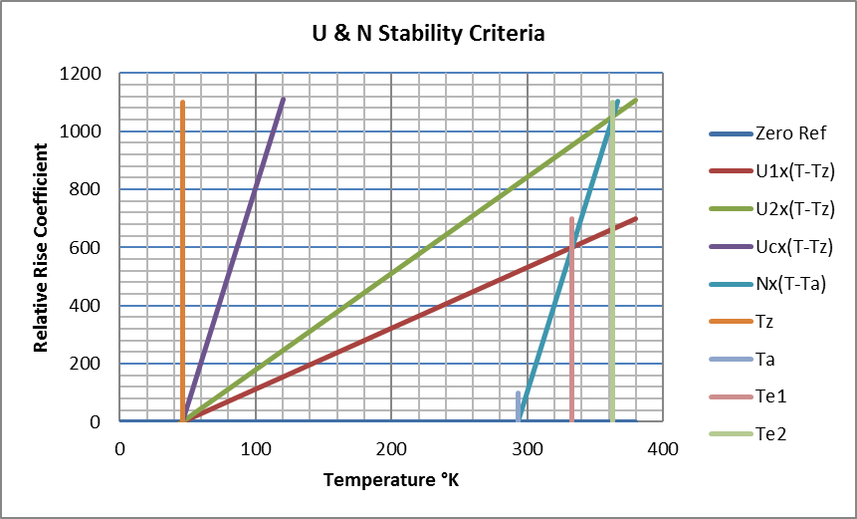

Importance of Variation in Resistivity with Temperature

As an aside, a constant rate of resistive heating, $U_{C}$, ignores temperature dependence and gives an inaccurate Equilibrium Temperature $\left({T^{'}}_{e}=T_{a}+\frac{U_{c}}{N}\right)$ with a formula predicting only stable temperature convergence and no capacity for divergent instability:
$$\left(T_{0}-{T^{'}}_{e}\right)=\left(T_{0}-{T^{'}}_{e}\right)\exp\left\{-Nt\right\}$$
An acceptable model of stability and equilibrium must account for the temperature variation of resistivity.

CDE Solutions with Axial (x) & Temporal (t) Variation
$$\frac{∂T}{∂t}=D\frac{∂^{2}T}{∂x^{2}}+\left(U-N\right)T+NT_{a}$$
With axial temperature variations included, the CDE now covers situations where conductor-temperature must adjust to boundary conditions at terminations and respond to imposed, or even spontaneous, disruptions.
CDE Solutions with Axial (x) & Temporal (t) Variation for Solutions with $U≠N$
For $U≠N$, the CDE can be separated as below:
$$T\left(x,t\right)=Z\left(x,t\right)+T_{e}\text{, where:} Z\left(x,t\right)=F\left(x\right)G\left(t\right) and: T_{e}=\frac{NT_{a}}{N-U}$$This accommodates multiple generic solutions of the form:
$$T=T_{e}+T_{m}\exp\left\{kx+ωt\right\}$$
The CDE then gives $ω=Dk^{2}+U-N and T=T_{e}+T_{m}\exp\left\{kx+\left(Dk^{2}+U-N\right)t\right\}$
Given their linearity with respect to temperature, the Z portions of these solutions can be superposed to fit boundary conditions:
$$T= T_{e}+\sum_{n}{T_{mn}\exp\left\{k_{n}x+\left(Dk_{n}^{2}+U-N\right)t\right\}}$$

CDE Solutions with Axial (x) & Temporal (t) Variation for $U<N$
For $U<N$, thermal stability is given by a negative temporal coefficient, $ω$ , ( $=Dk^{2}+U-N$) with spatial coefficient, $k$, real and zero or small $(k<√((N-U)/D)$; $k$ may be positive or negative to provide temporal and spatial convergence to equilibrium in central regions of uniform conductors away from end-effects.
The basic CDE solution allows temperature singularities formed by Fourier superposition of standing waves each with their own imaginary values for $k$. These increase the negative value of $ω$ and cause the temperature-structures to disperse over time.
Attenuated Undulation Amplitude with $U<N$ ($U=N$ at Current I_{critical} = 2.076kA)
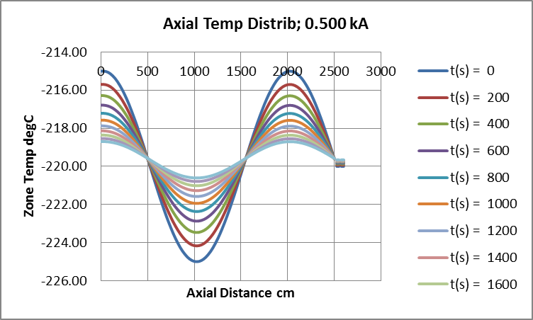
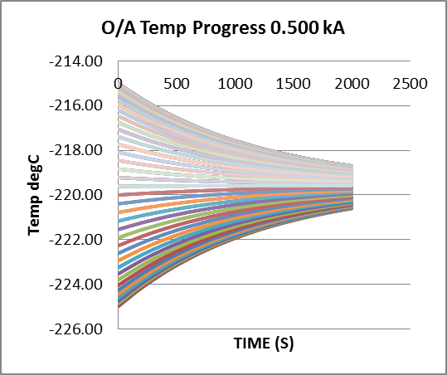
An initial undulate temperature distribution decays in amplitude.
If $U<N$, thermal behaviour of the conductor has intrinsic stability and dispels disruptions.

CDE Solutions with Axial (x) & Temporal (t) Variation for $U>N$
$U>N$ gives positive $ω$ and divergent temperature growth over time in central conductor regions away from any end-effects. As with zero axial variations, a bulk conductor or cable in this state suffers intrinsic instability. At terminations, connected thermal mass and cooling can reduce local conductor temperature by axial thermal conduction; imaginary$k$ with sufficient value to make the temporal coefficient, $ω$, zero or negative i.e., $\left(Dk^{2}+U-N\right)≤0$ then provides a possibility for stability. This condition, defined later in the later section on restrained equilibrium, is very useful and enables conductors with high, and otherwise unstable, loads to be restrained by end-cooling.
The basic CDE solution allows temperature singularities formed by Fourier superposition of standing waves each with their own imaginary values for $k$. Standing waves with wavelengths $λ$ require imaginary $k=ip$ giving $λ=\frac{2π}{p}$.
The CSE now shows that with $U>N$:
$$\text{For:} λ>2π\sqrt{D/{\left(U-N\right)}} \text{ω }\text{is positive and wave-amplitude grows over time.}$$
$$\text{For:} λ<2π\sqrt{D/{\left(U-N\right)}} \text{ω }\text{is negative and wave-amplitude shrinks over time.}$$
In approximate terms, singularities less than a critical width of about $π√(D/(U-N))$ will shrink over time whilst broader singularities will grow. Increasing the current therefore supports narrower temperature peaks and, in the extreme, this explains the occurrence of localised failures, as opposed to uniform destruction, in conductors suffering severe overloads. Variations in temperature can become amplified over time and lead to an exacerbation of random initial disturbances.
Extreme loading therefore not only unleashes divergent resistive heating but also presents a stochastic behaviour pattern for localised temperature growth and ultimate failure.
The possibility of standing temperature-waves has been proven by FEA modelling which has also verified numerically the effect of current loading and spatial-frequency on their growth or dispersion. Localised failure is clearly visible on many connectors damaged by overload currents.

Divergent Undulation Amplitude with $U>N$, ($U=N$ at Current I_{critical} = 2.076kA)
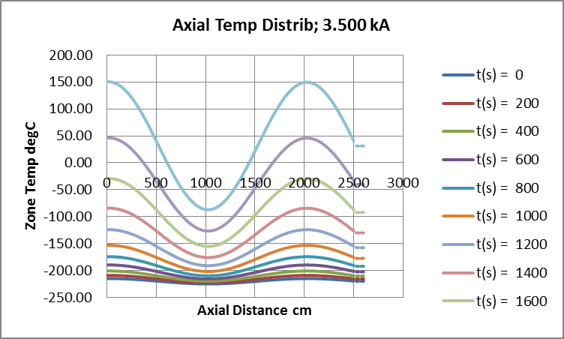
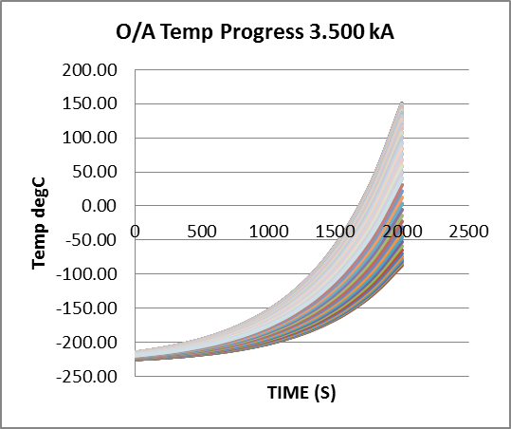
Conductor current enables growth in the initial undulate temperature distribution. Over the same period, baseline temperature increase is exponential.
If $U>N$, conductor thermal behaviour is unstable and subject to disruption by singularities unless restrained by adequate end-cooling.

CDE Solutions with Axial (x) & Temporal (t) Variation for $\left(U-N\right)→0$
At the point where $\left(U-N\right)$ transits through zero from negative to positive then $T_{e}$ and $T_{m}$ become very large offsets for temperatures in the linear working range:
$$T= T_{e}+T_{m}\exp\left\{kx+\left(Dk^{2}+U-N\right)t\right\}$$
Infinite $T_{e}$ forces reconsideration of solutions for the CDE:
$$\frac{∂T}{∂t}=D\frac{∂^{2}T}{∂x^{2}}+\left(U-N\right)T+NT_{a}$$
Previous examination of the ZAV case with both ${∂^{2}T}/{∂x^{2}}=0 \text{and}$ $\left(U-N\right)=0$ has already shown:
$$\frac{∂T}{∂t}=NT_{a} \text{\&} T=T_{0}+NT_{a}t$$
If examine, for $U≅N$ but $U<N$, a function with the form:
$$T=T_{0}+NT_{a}t+Aexp\left\{±\left(x-x_{0}\right)\sqrt{{\left(N-U\right)}/D}\right\}$$
Or, for $U≅N$ but $U>N$, a function with the form:
$$T=T_{0}+NT_{a}t+Acos\left\{\left(x-x_{0}\right)\sqrt{{\left(U-N\right)}/D}\right\}$$
Substitution into the CDE gives:
$$\frac{∂T}{∂t}=\left(N-U\right)\left(T_{0}+NT_{a}t\right)$$
This vanishes faster than the trial-function axial coefficients, $\sqrt{{\left(\left|N-U\right|\right)}/D}$ , if $\left|N-U\right|→0$.
Central portions of long conductors with zero axial temperature variation therefore revert to the ZAV situation for $U=N=W≠0$, with constant-rate temperature-rise that is linear and unlimited WRT time. This has been demonstrated in our own FEA modelling which, by iterating increase from $U=N$, also shows zero variation in amplitude of imposed sinusoidal temperature variations; undulate temperature distribution amplitude remains constant, baseline temperature increases at constant rate.
As with $U>N$, a standing wave can also be clamped by end-cooling at suitable terminations to stabilise otherwise overloaded conductors up to a finite length limit. This valuable situation is covered in the later section on constrained equilibria.
Stable Undulation Amplitude with $U≈N$ ($U=N$ at Current I_{critical} = 2.076kA)
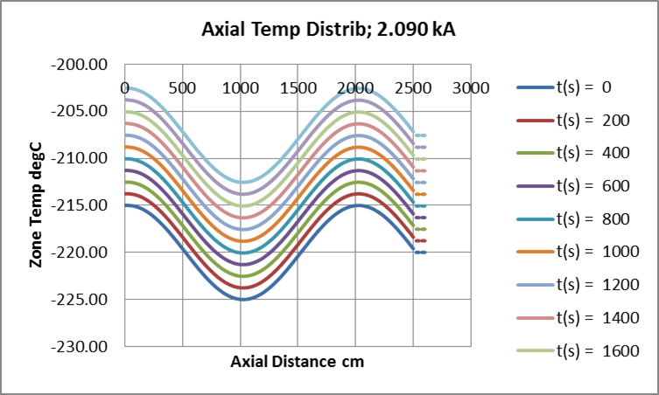
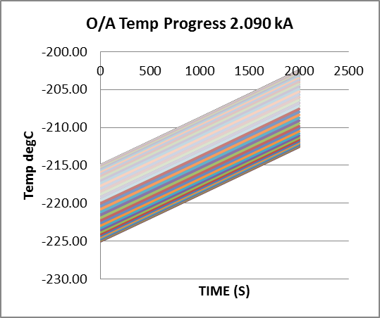

Constrained Spatial Equilibrium-Temperature Distributions
Thermal conduction at conductor terminations affects local temperatures and may also restrain an otherwise unstable conductor to equilibrium temperature-distribution over a finite length. Boundary conditions may be defined by temperature-gradient and heat-flux but calculations here are based on termination temperatures.
Thermal equilibria are indicated by $\frac{∂T}{∂t}$ approaching zero in the basic CDE:
$$\frac{∂T}{∂t}=D\frac{∂^{2}T}{∂x^{2}}+\left(U-N\right)T+NT_{a}=D\frac{∂^{2}T}{∂x^{2}}+\left(U-N\right)\left(T-T_{e}\right)$$
If thermal equilibrium can be achieved, then $\frac{∂T}{∂t}=0$ and we shall now look at possible thermal profiles where:
- $U<N$: Stable; Equilibrium profiles for all lengths with adaptation to boundary conditions.
- $U>N$: Unstable; Equilibrium profiles for finite lengths adapting to boundary conditions.
- $U=N$: Critical; Equilibrium profiles for finite lengths adapting to boundary conditions.

Condition (1): Stable; $U < N$
We know that equilibrium is possible for $U<N$ and can therefore apply $\frac{∂T}{∂t}=0$ to the CDE and obtain the axial dependence for temperature at thermal equilibrium:
$$D\frac{∂^{2}T}{∂x^{2}}+\left(U-N\right)\left(T-T_{e}\right)=0$$
Solutions with central $x=0$ are of the form:
$$T= T_{e}+T_{p}\exp\left\{\frac{2x}{b}\right\}+ T_{n}\exp\left\{-\frac{2x}{b}\right\}\text{, where:} b=2\sqrt{\frac{D}{\left(N-U\right)}}$$
If the cable terminates with $T=T_{c} \text{at }x=±c/2$, then:
$$T_{p}=T_{n}=\frac{\left(T_{c}-T_{e}\right)}{2}sech\left(c/b\right) \text{to give:} T=T_{e}-\left(T_{e}-T_{c}\right)sech\left(\frac{c}{b}\right)cosh\left(\frac{2x}{b}\right)$$
with central temperature given by: $T_{max}=T_{e}-\left(T_{e}-T_{c}\right)sech\left(c/b\right)$.
If $T_{e}>T_{p}$, temperature-profile intercepts with the axis ${T=T}_{z}=0$ occur at $x=±\frac{L_{zero}}{2}$given by:
$$L_{zero}=b.arcosh\left\{\frac{T_{e}cosh\left(c/b\right)}{\left(T_{e}-T_{c}\right)}\right\}\text{, where:} arcosh\left(z\right)=ln\left(z+\sqrt{z^{2}+1}\right)$$
For current-loading with $U < N$, the thermal profile (fig 01) provides equilibrium with environment in long central portions whilst adapting to temperature boundary-conditions at each end (e.g., a water-cooled heat-sink). If the conductor’s length is less than about $3b/2$ then the temperature will maximise at a noticeably lower level than $T_{e}$ with continuous temperature curvature between terminations (fig 02).

CSETD Fig 01
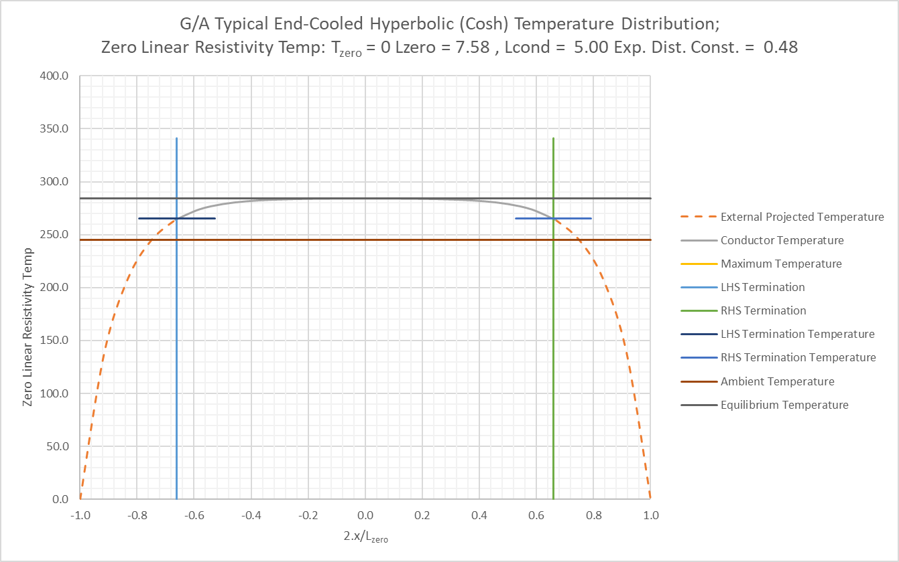
CSETD Fig 02
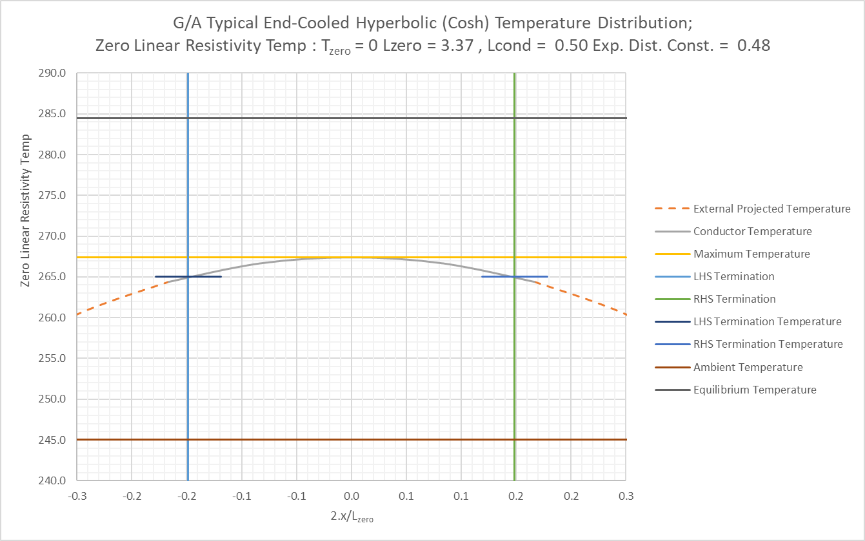

Condition (2): Unstable; $U > N$
If $U>N$ then a long conductor cannot reach equilibrium with the environment, but a conductor of finite length can be restrained at equilibrium with heat-sinking terminations; zero time-dependence requires the CDE to become:
$$D\frac{∂^{2}T}{∂x^{2}}+\left(U-N\right)T+NT_{a}=0$$
With central zero for axial distance:
$$T =T_{max}cos\left\{x\sqrt{\frac{U-N}{D}}\right\}+\frac{NT_{a}}{\left(U-N\right)}$$and $N=0$ gives:
$$T =T_{max}{cos\left\{x\sqrt{U/D}\right\}}$$
$N=0$ is worst-case pragmatic for stranded flexible connectors which need end-cooling to prevent over-heating at the centre. Termination temperatures, $T_{c}$, at separation $2c$ give:
$${ T}_{max}= T_{c}sec\left\{c\sqrt{U/D}\right\} \text{with temperature profile:} T= T_{c}sec\left\{c\sqrt{U/D}\right\}\cos\left\{x\sqrt{U/D}\right\}$$
$T=0$ with $x=±L_{zero}/2$ gives the total profile zero-point separation: $L_{zero}=π√(D/U)$ shown in the Cosine Temperature Distribution below.
Solutions for $N≠0$ require the offset and coefficient terms explained in the first solution above.
CSETD Fig 03

Condition (3): Critical; $U=N=W≠0$
Zero time-dependence with this condition requires:
$$D\frac{∂^{2}T}{∂x^{2}}+WT_{a}=0$$
With central zero for axial distance, temperature behaviour is therefore given by:
$$T=T_{max}- \frac{WT_{a}}{2D}x^{2}$$
Termination temperatures, $T_{c}$, at $x=±c$ provide $T_{max}$ at $x=0$:
$$T_{max}=T_{c}+ \frac{WT_{a}}{2D}c^{2}$$
Which defines the temperature profile:
$$T=T_{c}+\frac{WT_{a}}{2D}\left(c^{2}-x^{2}\right)$$
Remembering $T_{z}=0$ and $T=T_{max}$ when $x=0$; $T=0$ when $x=±\frac{L_{zero}}{2}$ gives:
$$L_{zero}=2\sqrt{\frac{2DT_{c}}{WT_{a}}+c^{2}}$$
Provided the maximum is acceptable, controlled-temperature terminations at finite separation can stabilise conductors with critical load-levels to Parabolic Temperature Distributions, as shown below.
CSETD Fig 04
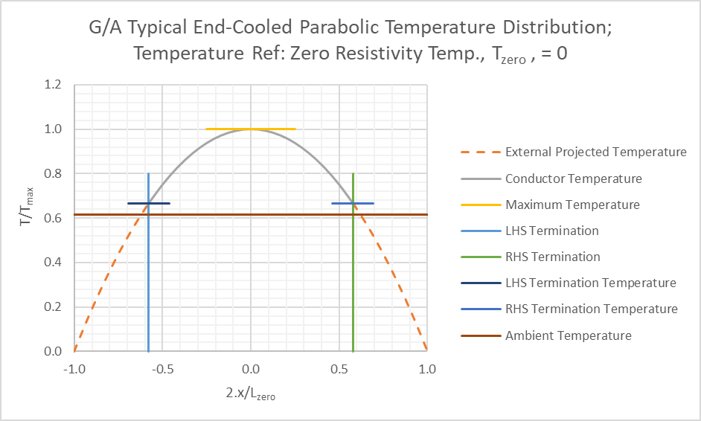

Case Study: High-Load Flexible Connections
A flexible connector between water-cooled end-blocks held at 70°C in high-temperature process equipment was showing severe degradation in service. The flexible connectors had an apparent external cross-section ITRO 2400 mm2 and length ITRO 117mm, but heavy cross-weaving led to actual cross-section ITRO 480mm2 and length ITRO 585mm. CD, and central temperature with 4.5 kA load are tabulated below for variations on estimated actual length and CSA:
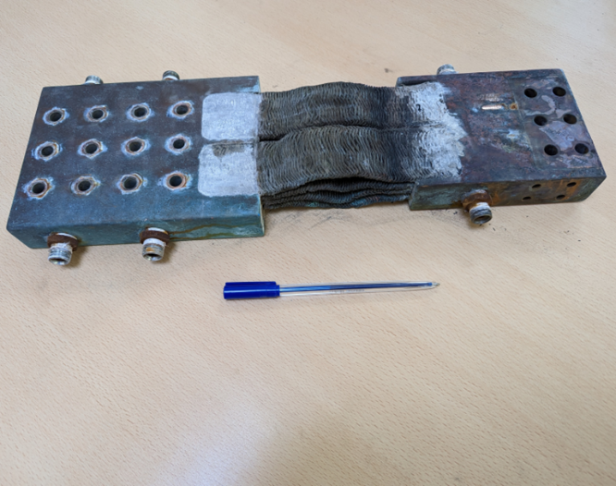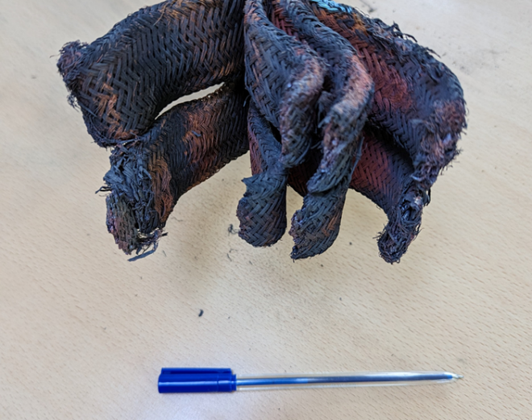

Original Flexible Connector, Conductor End-Block Temp = 70°C, Current Load = 4.50 kA
Flex. Conn. CS (mm²): |  | 540 | 508 | 480 | 455 | 432
4.5kA CD (A.mm⁻²): |  | 8.33 | 8.85 | 9.38 | 9.90 | 10.42
Lzero (m): |  | 0.902 | 0.849 | 0.802 | 0.760 | 0.722
Flex. Conn. L (m): |  | 0.520 | 0.553 | 0.585 | 0.618 | 0.650
 | Tmax (°C): | 253 | 340 | 490 | 792 | 1669

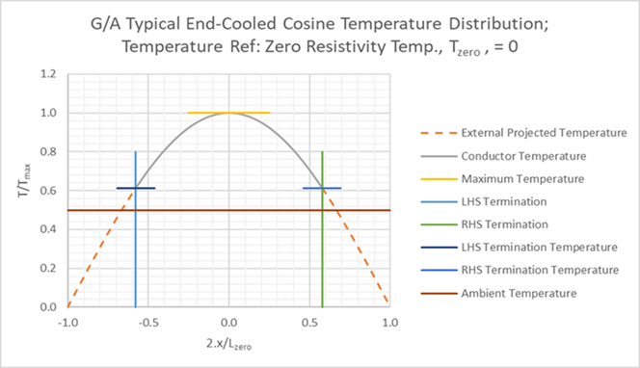
Flexible connectors were then re-specified to provide satisfactory CSA and length whilst retaining an adequate level of flexibility. Results are shown below:
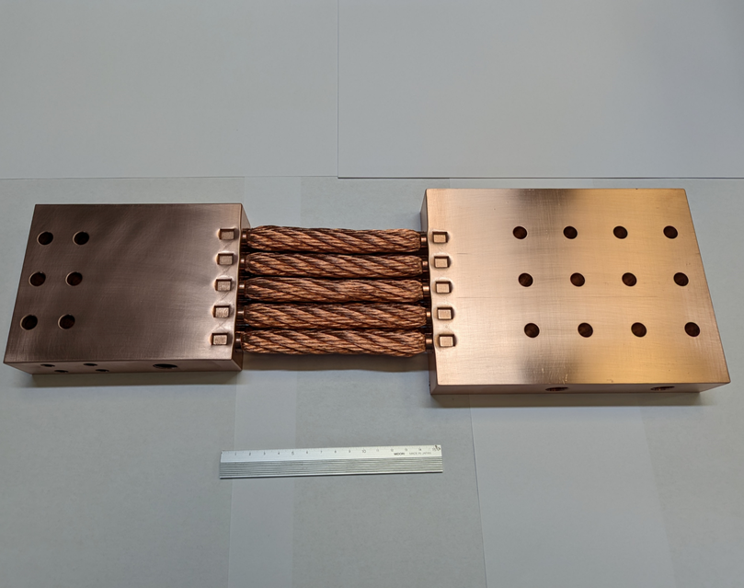
Re-Specified Flexible Connector
Conductor End-Block Temp = 70°C
Current Load = 4.50 kA
Flex. Conn. CS (mm²): | 950 | 950 | 950 | 950 | 950
Current Load (kA): | 4.00 | 4.25 | 4.50 | 4.75 | 5.00
CD (A.mm⁻²): | 4.21 | 4.47 | 4.74 | 5.00 | 5.26
Lzero (m): | 1.786 | 1.681 | 1.587 | 1.504 | 1.429
Flex. Conn. L (m): | 0.140 | 0.140 | 0.140 | 0.140 | 0.140
Tmax (°C): | 72.3 | 72.5 | 72.9 | 73.2 | 73.5

